Fundamentals Of Software Engineering Project Proposal

**DoccPlus - Deliverable - 3**

|  |  |
| --- | --- |
| **Name** | **Roll Number** |
| Abdul Saboor | L20-1113 |
| Fatima Azfar | L20-1027 |
| Mohammad Anas | L20-1289 |
| Komal Akhlaq | L20-1278 |
| Saad Ahmad Bhatti | L20-1264 |

Group Members:

CS2004 Fundamentals of Software Engineering

Spring 2022

Department of Computer Science

FAST-NU, Lahore, Pakistan

# Part 1:

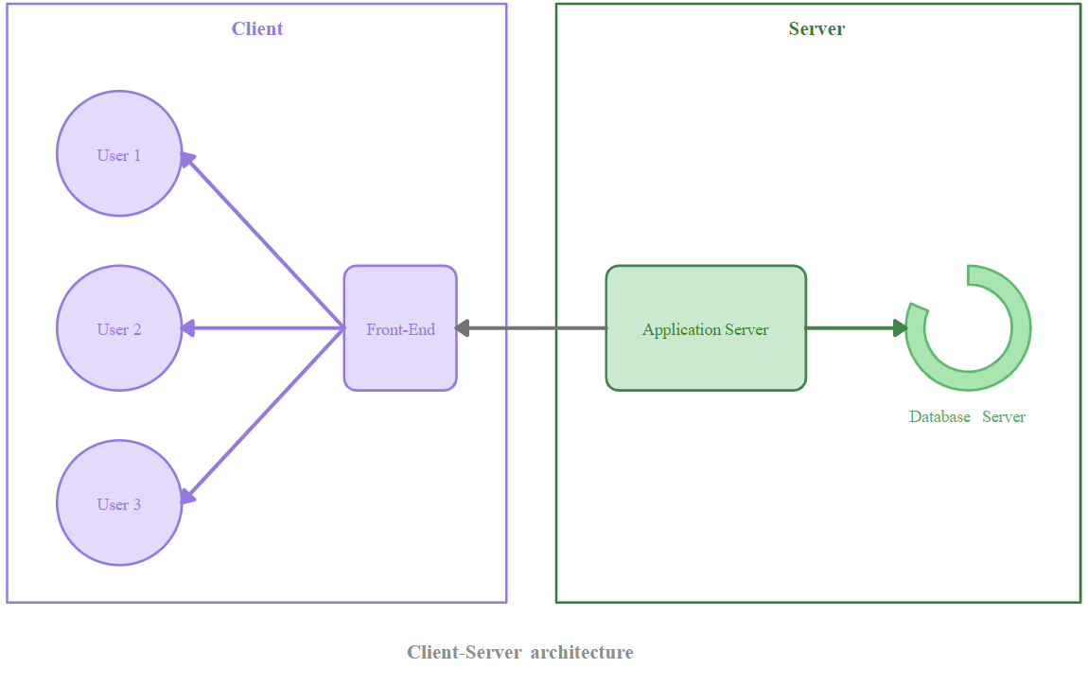

This architecture selection is appropriate because we have basically a user accessing all the information from a central cloud server. This server is located on a secure cloud instance. All the communication between both doctors and patients is handled through this central server.

This is the completed high-level diagram of the architecture and defines the placement of essential system components.

We have specifically used a client-server architecture because this is the inherent architecture for development and most mobile online mobile applications use this architecture in their implementation these days.

# Part 2:

Diagram given on next page